Acts 20:1-38
Luke does not tell us much about the next portion of the third journey. Paul revisits the churches established in Macedonia and Greece (Achaia).Paul's plan to sail to Syria from Achaia was changed when he discovered that the Jews had made a plot against him. He decided to return by land.
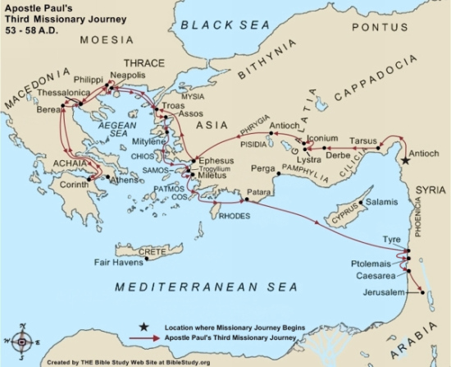

Through Macedonia and Greece
¹ When the uproar had ended, Paul sent for the disciples and, after encouraging them, said goodbye and set out for Macedonia. What was the uproar about? ² He traveled through that area, speaking many words of encouragement to the people, and finally arrived in Greece, ³ where he stayed three months. How long was Paul in Corinth? Because some Jews had plotted against him just as he was about to sail for Syria, he decided to go back through Macedonia. What caused Paul to change his plans? ⁴ He was accompanied by Sopater son of Pyrrhus from Berea, Aristarchus and Secundus from Thessalonica, Gaius from Derbe, Timothy also, and Tychicus and Trophimus from the province of Asia. Where were these men from? ⁵ These men went on ahead and waited for us at Troas. Where did Paul send some of his traveling companions? ⁶ But we sailed from Philippi after the Festival of Unleavened Bread, and five days later joined the others at Troas, where we stayed seven days. Who else is with Paul?

Eutychus Raised From the Dead at Troas
⁷ On the first day of the week we came together to break bread. Why did the people gather? Paul spoke to the people and, because he intended to leave the next day, kept on talking until midnight. How long had Paul been talking? ⁸ There were many lamps in the upstairs room where we were meeting. ⁹ Seated in a window was a young man named Eutychus, who was sinking into a deep sleep as Paul talked on and on. Where was Eutychus sitting? When he was sound asleep, he fell to the ground from the third story and was picked up dead. What just happened? ¹⁰ Paul went down, threw himself on the young man and put his arms around him. “Don’t be alarmed,” he said. “He’s alive!” What miracle did Paul perform? ¹¹ Then he went upstairs again and broke bread and ate. After talking until daylight, he left. How long did Paul stay? ¹² The people took the young man home alive and were greatly comforted.

Paul’s Farewell to the Ephesian Elders
¹³ We went on ahead to the ship and sailed for Assos, where we were going to take Paul aboard. He had made this arrangement because he was going there on foot. What had Paul decided?¹⁴ When he met us at Assos, we took him aboard and went on to Mitylene. ¹⁵ The next day we set sail from there and arrived off Chios. The day after that we crossed over to Samos, and on the following day arrived at Miletus. ¹⁶ Paul had decided to sail past Ephesus to avoid spending time in the province of Asia, for he was in a hurry to reach Jerusalem, if possible, by the day of Pentecost. Why did Paul decide to sail past Ephesus?
¹⁷ From Miletus, Paul sent to Ephesus for the elders of the church. Who did Paul meet in Miletus? ¹⁸ When they arrived, he said to them: “You know how I lived the whole time I was with you, from the first day I came into the province of Asia. ¹⁹ I served the Lord with great humility and with tears and in the midst of severe testing by the plots of my Jewish opponents. What is Paul reminding the elders? ²⁰ You know that I have not hesitated to preach anything that would be helpful to you but have taught you publicly and from house to house. ²¹ How has Paul taught the people? I have declared to both Jews and Greeks that they must turn to God in repentance and have faith in our Lord Jesus. Who has Paul taught? Why would Paul talk about how he spent his time with them?
²² “And now, compelled by the Spirit, I am going to Jerusalem, not knowing what will happen to me there. Who is directing Paul to go to Jerusalem? ²³ I only know that in every city the Holy Spirit warns me that prison and hardships are facing me. What does Paul know lies ahead? ²⁴ However, I consider my life worth nothing to me; my only aim is to finish the race and complete the task the Lord Jesus has given me—the task of testifying to the good news of God’s grace. What race is Paul speaking about?
²⁵ “Now I know that none of you among whom I have gone about preaching the kingdom will ever see me again. What does Paul want the elders to know? ²⁶ Therefore, I declare to you today that I am innocent of the blood of any of you. What does Paul mean by verse 26? ²⁷ For I have not hesitated to proclaim to you the whole will of God. What has Paul taught the elders from Ephesus? ²⁸ Keep watch over yourselves and all the flock of which the Holy Spirit has made you overseers. Be shepherds of the church of God, which he bought with his own blood. What responsibility did these men have? ²⁹ I know that after I leave, savage wolves will come in among you and will not spare the flock. What is Paul's warning? ³⁰ Even from your own number men will arise and distort the truth in order to draw away disciples after them. Where will these distorters of truth come from? ³¹ So be on your guard! Remember that for three years I never stopped warning each of you night and day with tears.
³² “Now I commit you to God and to the word of his grace, which can build you up and give you an inheritance among all those who are sanctified. What will God's Word give them? ³³ I have not coveted anyone’s silver or gold or clothing. ³⁴ You yourselves know that these hands of mine have supplied my own needs and the needs of my companions. How did Paul take care of his needs while he traveled? ³⁵ In everything I did, I showed you that by this kind of hard work we must help the weak, remembering the words the Lord Jesus himself said: ‘It is more blessed to give than to receive.’ ” Who must we help?
³⁶ When Paul had finished speaking, he knelt down with all of them and prayed. How did Paul finish his meeting? ³⁷ They all wept as they embraced him and kissed him. ³⁸ What grieved them most was his statement that they would never see his face again. What grieved the men? Then they accompanied him to the ship.

